Garden Fresh Food Mart – Point of sale.
User Manual
Introduction
Garden Fresh Manager is a simple inventory and sales management system designed to help you:
- Manage garden products (Carrots, Potatoes, Matooke, Cabbages, etc.)
- Record stock purchases
- Track product quantities
- Record sales
- Automatically calculate profits using FIFO costing
- Record business expenses
- Monitor stock levels
- Generate financial reports for specific date ranges

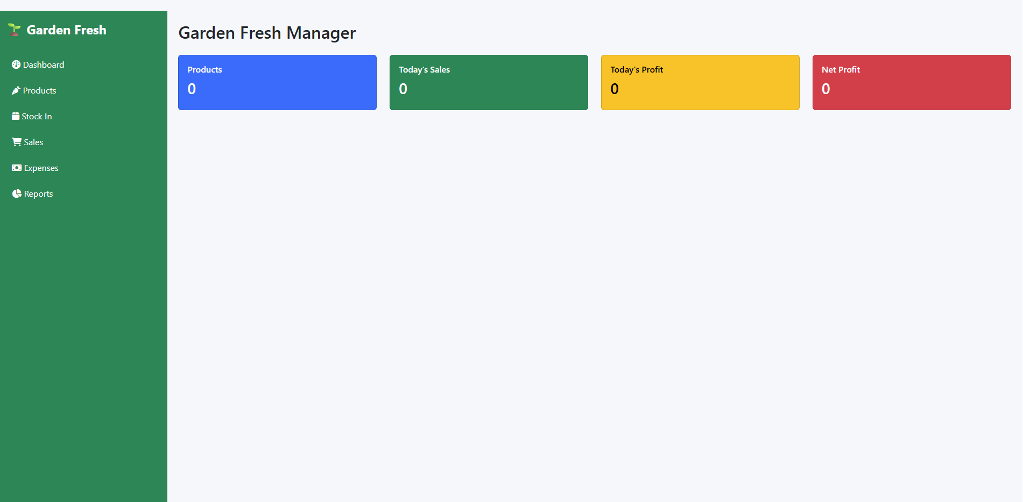
Step 1: Access the System – Once hosted, it will be accessed online.
Start the Django server:
Shell
python manage.py runserver
Open your browser and visit:
Plain Text
http://127.0.0.1:8000/
You will see the Garden Fresh Manager Dashboard.

Step 2: Add Products
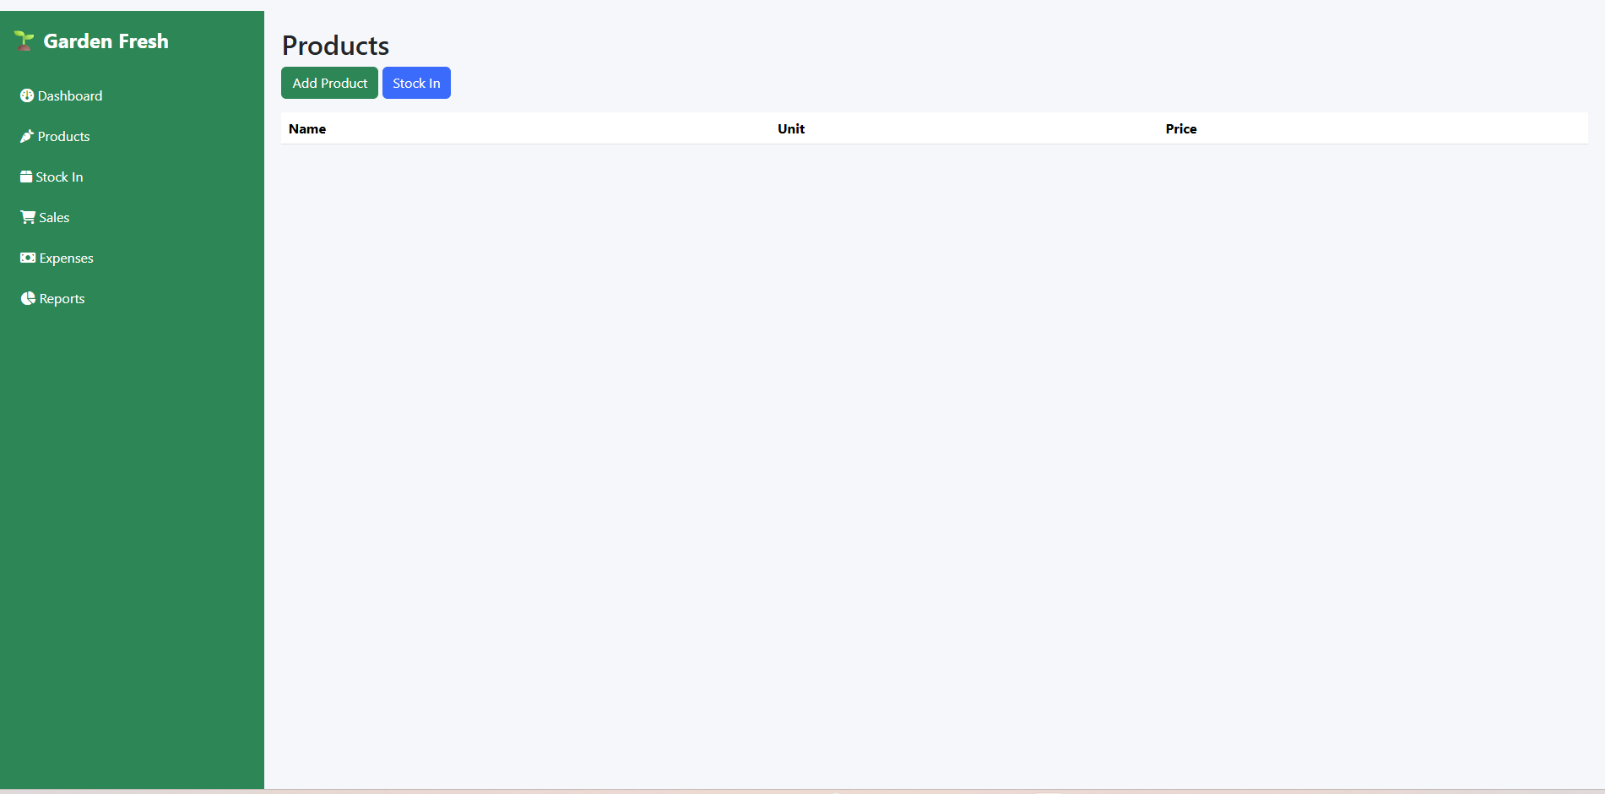
Before recording stock or sales, products must be created.
Navigate To
Plain Text
Products
Click
Plain Text
Add Product
Enter Details
Example:
Field | Value
Name | Carrots
Unit | Piece
Selling Price | 1000
Save
The product is now available for stock management and sales.

Step 3: Add Stock
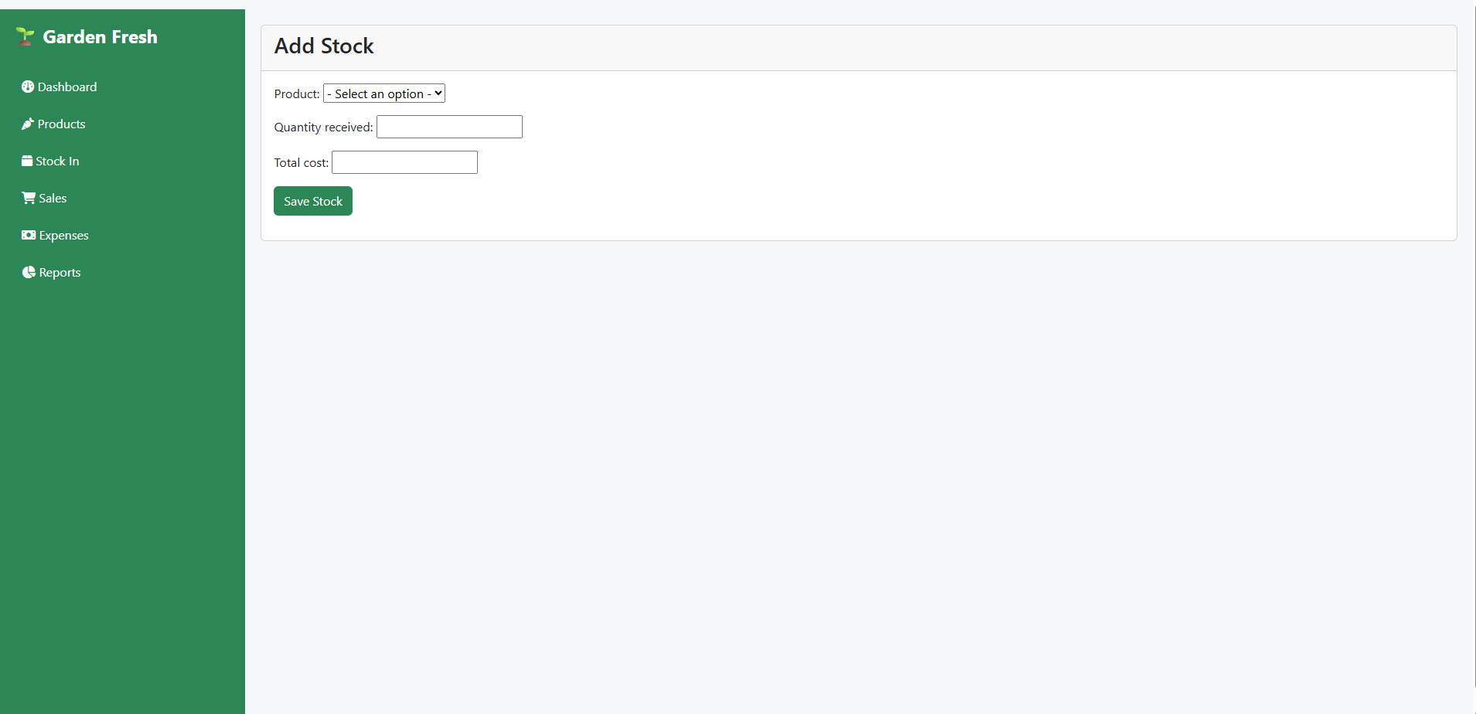
When new stock arrives, record it using the Stock In module.
Navigate To
Plain Text
Stock In
Example
If you purchase:
Plain Text
Carrots
Quantity: 20
Total Cost: 5000
Enter:
Field | Value
Product | Carrots
Quantity Received | 20
Total Cost | 5000
Save Stock
The system automatically calculates:
Plain Text
Unit Cost = 5000 ÷ 20
= UGX 250
Stock is now available for sale.

Step 4: Record Sales
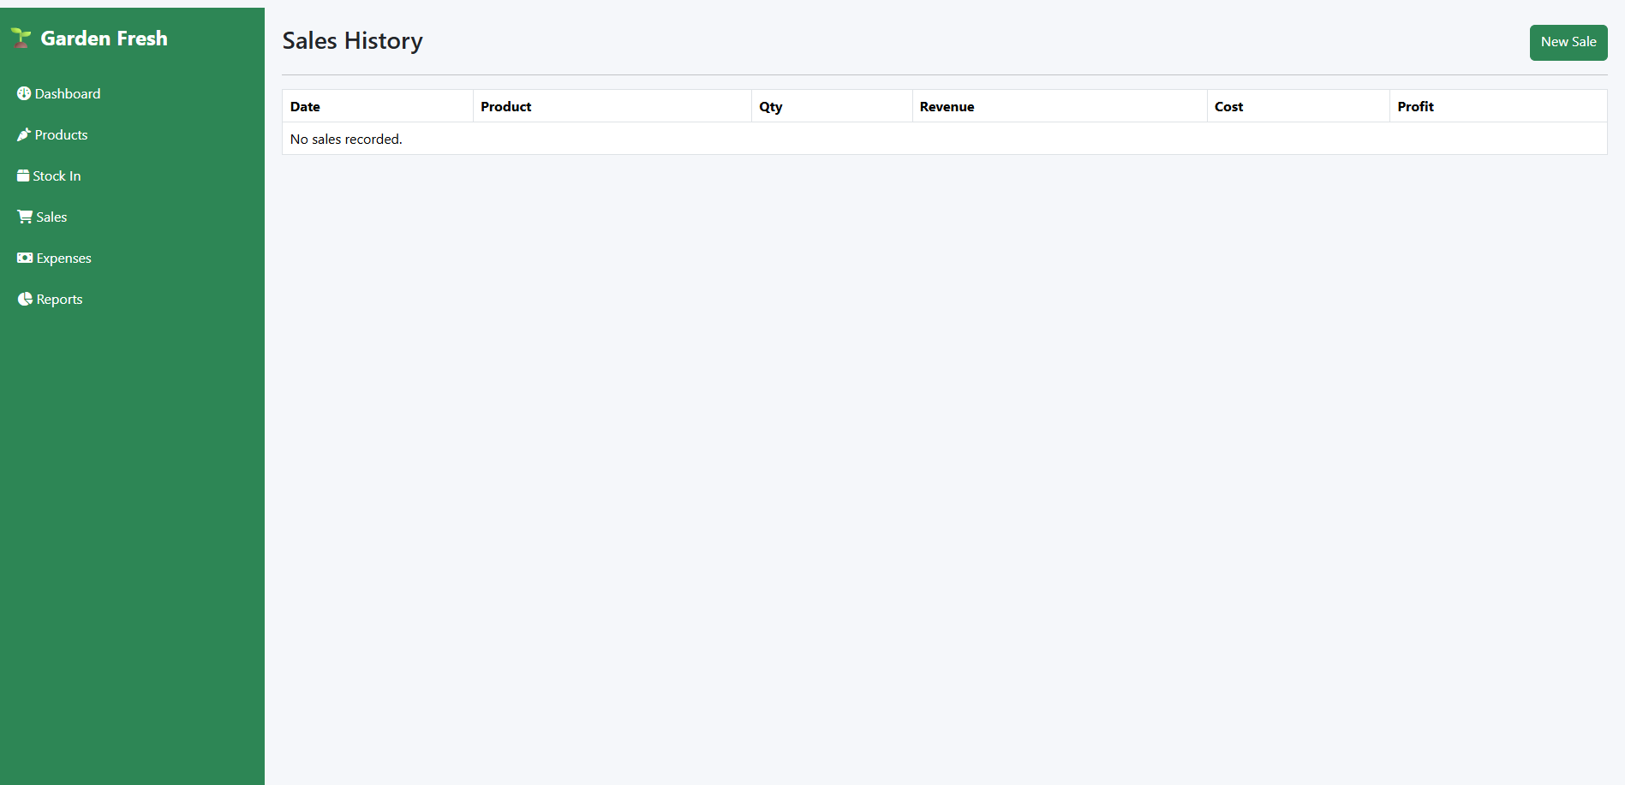
Navigate To
Plain Text
Sales
Click
Plain Text
New Sale
Example
Sell:
Plain Text
Carrots
Quantity: 7
Sale Price: 1000
Enter:
Field | Value
Product | Carrots
Quantity | 7
Unit Sale Price | 1000
Click:
Plain Text
Complete Sale
System Automatically Calculates
Revenue:
Plain Text
7 × 1000 = 7000
Cost:
Plain Text
7 × 250 = 1750
Profit:
Plain Text
7000 - 1750 = 5250

Step 5: FIFO Inventory Deduction
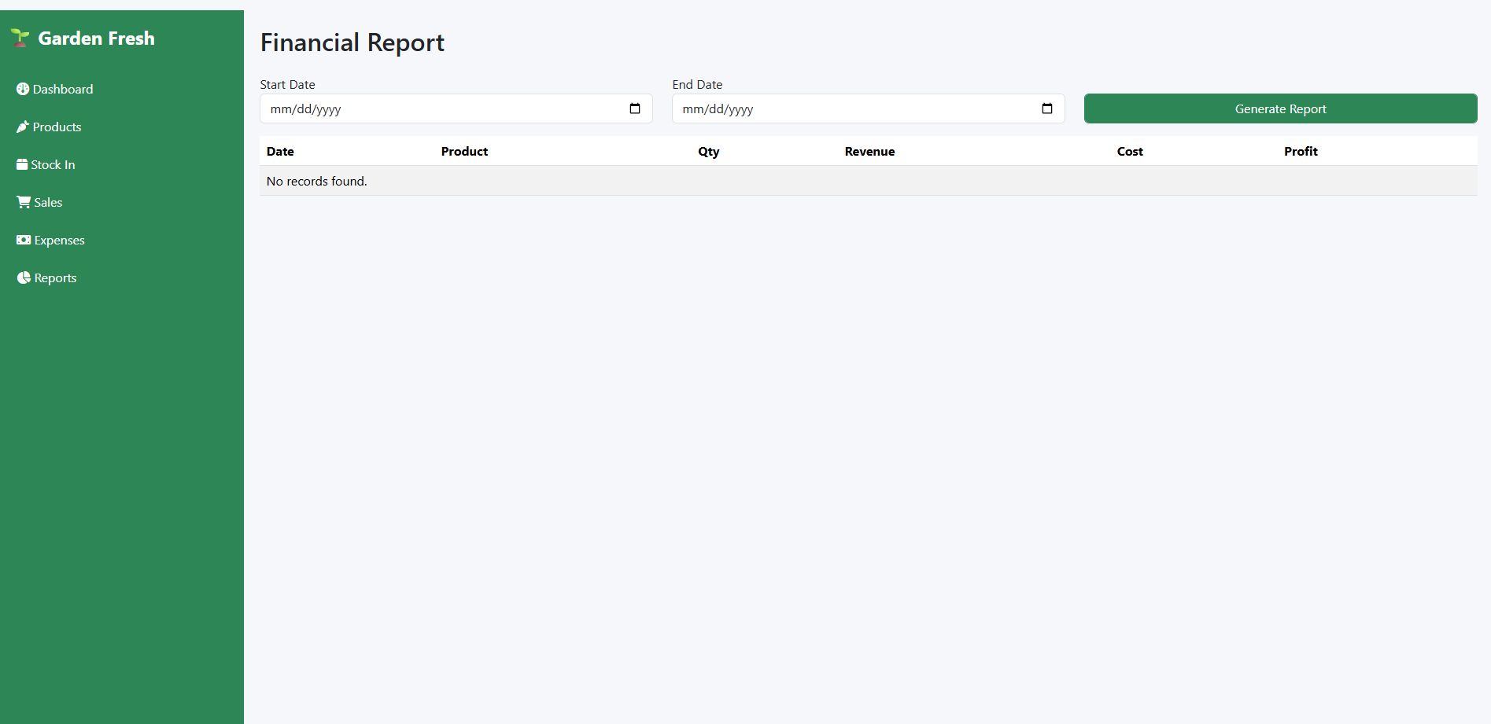
The system uses:
Plain Text
FIFO
(First In First Out)
This means older stock is sold before newer stock.
Example
Batch 1
Plain Text
20 Carrots
Cost = 250 each
Batch 2
Plain Text
10 Carrots
Cost = 400 each
If you sell:
Plain Text
25 Carrots
The system deducts:
Plain Text
20 from Batch 1
5 from Batch 2
and calculates the correct profit automatically.

Step 6: View Current Stock
Go To
Plain Text
Products
You can view:
- Product Name
- Selling Price
- Available Stock
The available quantity updates automatically after every sale.

Step 7: Record Expenses
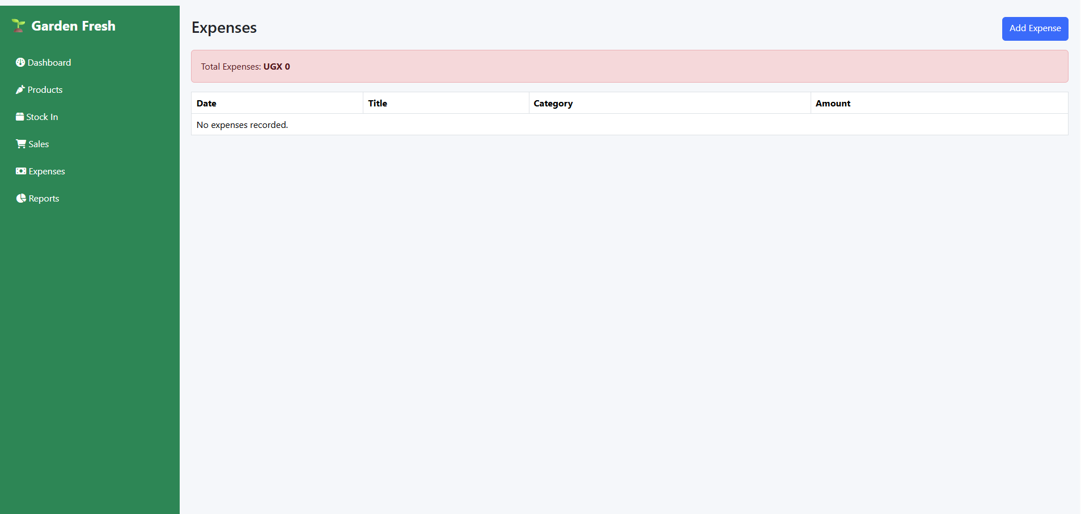
Business expenses should be recorded regularly.
Navigate To
Plain Text
Expenses
Click
Plain Text
Add Expense
Example
Field | Value
Title | Transport
Category | Transport
Amount | 20000
Date | Today's Date
Save Expense
The expense will be included in financial reports and net profit calculations.

Step 8: View Dashboard
The dashboard provides real-time business insights.
Navigate To
Plain Text
Dashboard
Key Indicators
Products
Shows total number of products.
Example:
Plain Text
15 Products
Total Stock
Current stock quantity available.
Example:
Plain Text
250 Items
Stock Value
Value of inventory currently in stock.
Example:
Plain Text
UGX 1,250,000
Today's Sales
Example:
Plain Text
UGX 350,000
Today's Profit
Example:
Plain Text
UGX 120,000
Today's Expenses
Example:
Plain Text
UGX 30,000
Net Profit
Example:
Plain Text
UGX 90,000

Step 9: Generate Financial Reports
Navigate To
Plain Text
Reports
Select
Plain Text
Start Date
End Date
Example:
Plain Text
01/10/2026
31/10/2026
Click
Plain Text
Generate Report
The system displays:
- Total Revenue
- Cost of Goods Sold
- Gross Profit
- Expenses
- Net Profit
- Sales Transactions
- Top Selling Products

Step 10: Interpret Report Metrics
Revenue
Total money received from sales.
Example:
Plain Text
UGX 500,000

Cost of Goods Sold (COGS)
Actual cost of products sold.
Example:
Plain Text
UGX 250,000

Gross Profit
Plain Text
Revenue - Cost
Example:
Plain Text
500,000 - 250,000
= UGX 250,000

Expenses
Business operational costs.
Example:
Plain Text
UGX 70,000

Net Profit
Plain Text
Gross Profit - Expenses
Example:
Plain Text
250,000 - 70,000
= UGX 180,000

Daily Operating Procedure
At the beginning of the day:
✅ Add newly purchased stock
During the day:
✅ Record every sale
✅ Record every expense
At the end of the day:
✅ Review Dashboard
✅ Generate Daily Report
✅ Verify Stock Levels
✅ Review Profit and Net Profit

Best Practices
- Record stock immediately upon purchase.
- Record every sale as it occurs.
- Enter expenses on the same day they occur.
- Regularly review low-stock products.
- Use reports to monitor profitability.
- Verify stock balances weekly.
- Back up the database regularly.

Navigation Menu Summary
Plain Text
🌱 Dashboard
🥕 Products
📦 Stock In
🛒 Sales
💰 Expenses
📊 Reports
This workflow ensures accurate stock tracking, FIFO profit calculation, expense management, and complete visibility into the performance of your garden shop.

